Lab Assignment #1

Introduction to Patran
Displacement and Stress Computations of Truss Structures using Axial Finite Elements

EAE 133 - Finite Element Methods in Structures
Professor N. Sarigul-Klijn
TA: Noah Derita

Aurian Malhotra
920005606
Section A04, 10/2/2025

Introduction
The purpose of this lab is to get accustomed to Patran, generally. In doing so my goal is to find the nodal displacements in global directions and axial stresses in each member of the given truss structure. Using Patran, I add the given steel structure, create a mesh, and analyze using Finite Element Methods. Then I repeat this process with a new material of my choice, Aluminum.

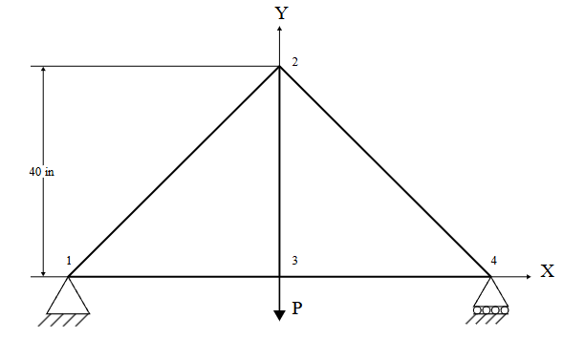

Procedure
Starting off I made a new file and set the Approximate Maximum Model Dimension to 140 and Analysis Code to MSC.NASTRAN. Then I began modeling the Geometry starting with creating four XYZ points for the four joints shown in the truss structure at [-1.524 0 0] [0 1.016 0] [0 0 0] and [1.524 0 0] respectively. Finishing off geometry the four points were connected using linear curves.

The truss structure was then given the properties of steel with a linear elastic constitutive model. Using Elastic Modulus 2e11 Pa (N/m²) and a Poisson Ratio of 0.3. The vertical rod was assigned a 1.75 in² (0.0112903 m²) cross-sectional area while the remaining four steel rods were assigned 2.0 in² (0.00129032 m²) cross-sectional area.

Next I added the BC for the pin and roller joints. A node is added to points 1 and 4 for the pin and roller joints, node 1 has no directional freedom while 4 has freedom in the x-direction. Next a point load was added at point 3 with a magnitude of -5000 lbf (-22,241 N), negative for the negative y-direction.

Each rod then received a mesh seed, then a full mesh was created over the entire structure. Finally I conducted a Linear Static analysis on the truss yielding the results. The load case, including both supports and the applied load, was assigned to the analysis run. The job was executed through MSC.NASTRAN, generating an .f06 and .xdb file. Results were attached from the .xdb file and the fringe and deformation plots displayed stress tensor and translational displacement.
Results

Figure 1: Case 1, Steel Rods
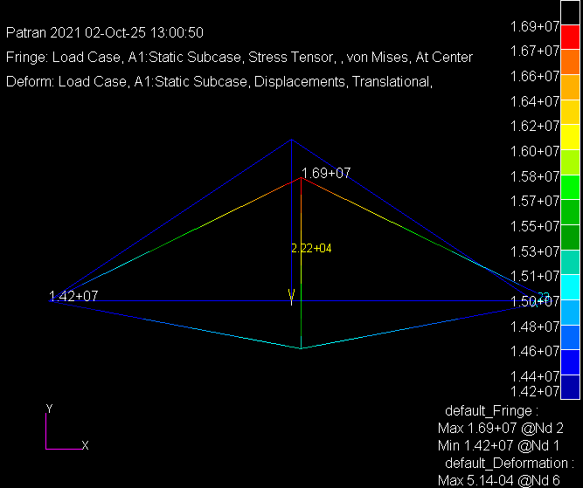

Figure 2: Case 2, Aluminum Rods
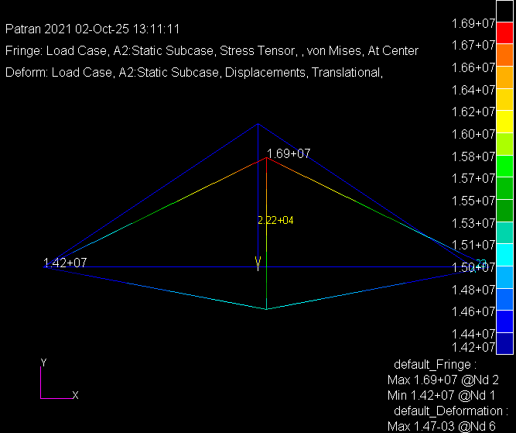

Stresses and Displacement Tables

Table 1: Axial Stresses in Truss Members
Truss Member Element ID and corresponding Nodes | Axial Stress (Pa)
 | 1  (1-2) | 2  (2-4) | 3  (2-3) | 4  (3-4) | 5  (1-4)
Steel | -1.553729E+07 | -1.553729E+07 | 1.969973E+07 | 1.292781E+07 | 1.292781E+07
Aluminum | -1.553729E+07 | -1.553729E+07 | 1.969973E+07 | 1.292781E+07 | 1.292781E+07

Table 2: Nodal Displacements
Node # |  | Displacements (m)
 |  | 1 |  | 2 |  | 3  (Point ID 4) |  | 4  (Point ID 3)
 |  | X | Y | X | Y | X | Y | X | Y
Steel |  | 0.0 | 0.0 | 9.850990E-05 | -4.042855E-04 | 9.850990E-05 | -5.043602E-04 | 1.970198E-04 | 0.0
Aluminum |  | 0.0 | 0.0 | 2.814568E-04 | -1.155101E-03 | 2.814568E-04 | -1.441029E-03 | 5.629137E-04 | 0.0

Discussion/Conclusion

Since both models shared the same geometry, loading, and boundary conditions, the internal stresses within each truss member remained consistent between the steel and aluminum cases. The primary difference arose in deformation behavior due to material stiffness. Aluminum, having a much lower Young’s modulus than steel, exhibited noticeably greater displacement under the same load. Its slightly higher Poisson’s ratio also contributed to larger lateral strain.

As expected for a truss modeled with 1-D rod elements, only axial stresses developed in the members. The highest stress was observed along the upper chord near Node 2, while the lowest occurred near the pinned support at Node 1. Node 3 showed the greatest overall deformation, corresponding to the point of applied load and absence of any boundary restraints.

